CAR RENTAL SHOP

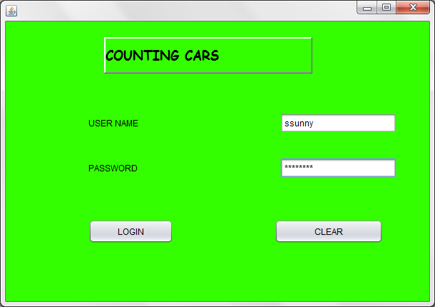

FOR LOGIN

String s1=t1.getText();

String s2=new String(p1.getPassword());

if(s1.equalsIgnoreCase("ssunny")&& s2.equals("mercedes"))

{

new frame1().setMaximumSize(null);

new frame1().setVisible(true);

}

else

{

j1.showMessageDialog(null,"incorrect usernam/password");

}

new frame2().dispose();

FOR CLEAR

t1.setText(" ");

p1.setText(" ");

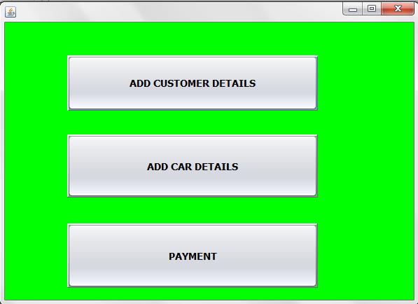

FOR ‘ADD CUSTOMER DETAILS’

new frame2().setMaximumSize(null);

new frame2().setVisible(true);

FOR ADD CAR DETAILS

new frame3().setMaximumSize(null);

new frame3().setVisible(true);

FOR PAYMENT

new frame4().setMaximumSize(null);

new frame4().setVisible(true);

FOR CUSTOMER DETAILS

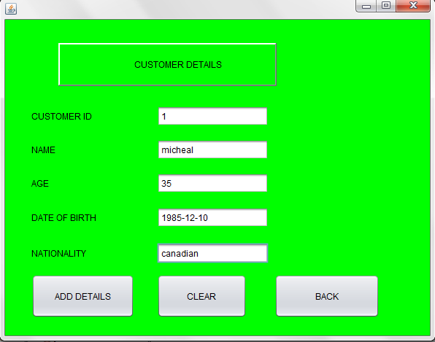

FOR ADD DETAILS BUTTON

try{

Class.forName("com.mysql.jdbc.Driver");

Class.forName("java.sql.Driver");

Connection con=DriverManager.getConnection("jdbc:mysql://localhost:3306/counting_cars","root","agp3sss");

String q="insert into car values('"+t7.getText()+"','"+t8.getText()+"','"+t9.getText()+"',"+");";

Statement stmt= (Statement) con.createStatement();

stmt.executeUpdate(q);

j4.showMessageDialog(null,"Record added");

stmt.close();

con.close();

}catch(Exception e){

j5.showMessageDialog(null,e.getMessage());

}

FOR CLEAR BUTTON

t7.setText(" ");

t8.setText(" ");

t9.setText(" ");

FOR BACK BUTTON

new frame1().setMaximumSize(null);

this.setVisible(false);

FOR PAYMENT

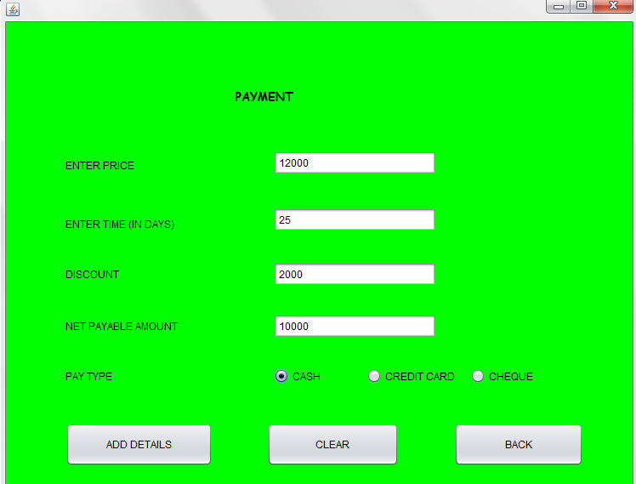

FOR ADD DETAILS BUTTON

try{

Class.forName("com.mysql.jdbc.Driver");

Class.forName("java.sql.Driver");

Connection con=DriverManager.getConnection("jdbc:mysql://localhost:3306/counting_cars","root","agp3sss");

String q="insert into payment values("+t10.getText()+","+t11.getText()+","+t12.getText()+","+t13.getText()+" "+");";

Statement stmt= (Statement) con.createStatement();

double p=Double.parseDouble(t10.getText());

double t=Double.parseDouble(t11.getText());

double amount=p*t;

double discount=0;

double net=0;

if(o1.isSelected()==true)

{

discount=(11*amount)/100;

}

else if(o2.isSelected()==true)

{

discount=(0*amount)/100;

}

else if(o3.isSelected()==true)

{

discount=(2*amount)/100;

}

t12.setText(" "+discount);

net=p-discount;

t13.setText(" "+net);

stmt.executeUpdate(q);

j6.showMessageDialog(null,"Record added");

stmt.close();

con.close();

}catch(Exception e){

j7.showMessageDialog(null,e.getMessage());

}

}

FOR CLEAR BUTTON

t10.setText(" ");

t11.setText(" ");

t12.setText(" ");

t13.setText(" ");

FOR BACK BUTTON

new frame2().setMaximumSize(null);

this.setVisible(false);

FOR RETRIEVING CUSTOMER DETAILS

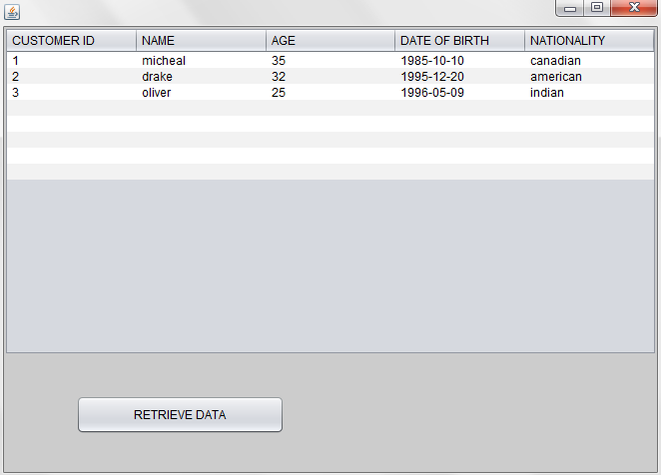

FOR RETRIEVE BUTTON

DefaultTableModel model=(DefaultTableModel) T1.getModel();

try{

Class.forName("java.sql.Driver");

Connection con=DriverManager.getConnection("jdbc:mysql://localhost/counting_cars","root","agp3sss");

Statement stmt=con.createStatement();

String query="select * from customer;";

ResultSet rs=stmt.executeQuery(query);

while(rs.next()){

String custid=rs.getString("cust_id");

String name=rs.getString("name");

String age=rs.getString("age");

String dateofbirth=rs.getString("dateofbirth");

String nationality=rs.getString("nationality");

model.addRow(new Object[] {custid,name,age,dateofbirth,nationality});

}

rs.close();

stmt.close();

con.close();

}catch(Exception e){

j8.showMessageDialog(null,"error in conectiivity");

}

FOR RETRIEVING CAR DETAILS

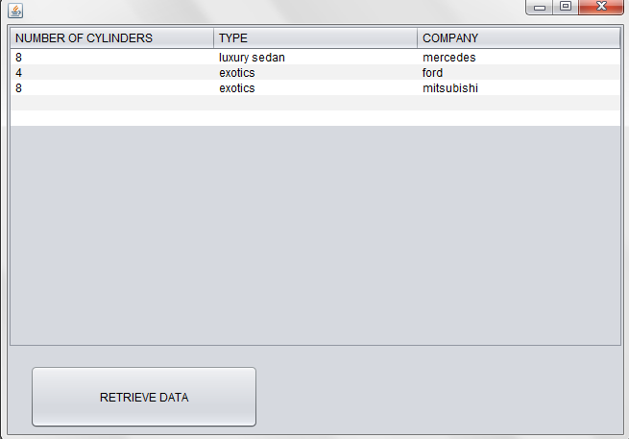

FOR RETRIEVING DATA BUTTON

DefaultTableModel model=(DefaultTableModel) T2.getModel();

try{

Class.forName("java.sql.Driver");

Connection con=DriverManager.getConnection("jdbc:mysql://localhost/counting_cars","root","agp3sss");

Statement stmt=con.createStatement();

String query="select * from car;";

ResultSet rs=stmt.executeQuery(query);

while(rs.next()){

String num=rs.getString("num_cylinders");

String type=rs.getString("type");

String company=rs.getString("company");

model.addRow(new Object[] {num,type,company});

}

rs.close();

stmt.close();

con.close();

}catch(Exception e){

j9.showMessageDialog(null,"error in conectiivity");

}

}

FOR RETRIEVING PAYMENT DETAILS

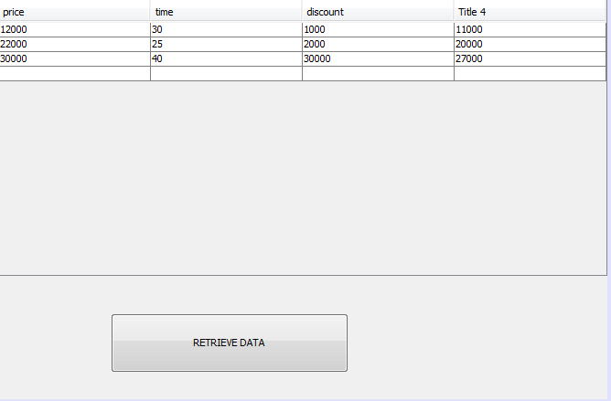

FOR RETRIEVING DATA BUTTON

DefaultTableModel model=(DefaultTableModel) T3.getModel();

try{

Class.forName("java.sql.Driver");

Connection con=DriverManager.getConnection("jdbc:mysql://localhost/counting_cars","root","agp3sss");

Statement stmt=con.createStatement();

String query="select * from payment;";

ResultSet rs=stmt.executeQuery(query);

while(rs.next()){

String price=rs.getString("num_cylinders");

String time=rs.getString("type");

String discount=rs.getString("company");

String pay=rs.getString("payable_amount");

model.addRow(new Object[] {price,time,discount,pay});

}

rs.close();

stmt.close();

con.close();

}catch(Exception e){

J1.showMessageDialog(null,"error in conectiivity");

}

}

}

/**

* @param args the command line arguments

*/

public static void main(String args[]) {

/* Set the Nimbus look and feel */

//<editor-fold defaultstate="collapsed" desc=" Look and feel setting code (optional) ">

/* If Nimbus (introduced in Java SE 6) is not available, stay with the default look and feel.

* For details see http://download.oracle.com/javase/tutorial/uiswing/lookandfeel/plaf.html

*/

try {

for (javax.swing.UIManager.LookAndFeelInfo info : javax.swing.UIManager.getInstalledLookAndFeels()) {

if ("Nimbus".equals(info.getName())) {

javax.swing.UIManager.setLookAndFeel(info.getClassName());

break;

}

}

} catch (ClassNotFoundException ex) {

java.util.logging.Logger.getLogger(frame7.class.getName()).log(java.util.logging.Level.SEVERE, null, ex);

} catch (InstantiationException ex) {

java.util.logging.Logger.getLogger(frame7.class.getName()).log(java.util.logging.Level.SEVERE, null, ex);

} catch (IllegalAccessException ex) {

java.util.logging.Logger.getLogger(frame7.class.getName()).log(java.util.logging.Level.SEVERE, null, ex);

} catch (javax.swing.UnsupportedLookAndFeelException ex) {

java.util.logging.Logger.getLogger(frame7.class.getName()).log(java.util.logging.Level.SEVERE, null, ex);

}

//</editor-fold>

/* Create and display the form */

java.awt.EventQueue.invokeLater(new Runnable() {

public void run() {

new frame7().setVisible(true);

}

